ICCCN 2018

The way to the Conference Venue

Venue:
Hangzhou Sunday Sunny Resort (杭州三台山庄)
Address: No. 200 Santaishan Road, Xihu District, Hangzhou City, Zhejiang Province.
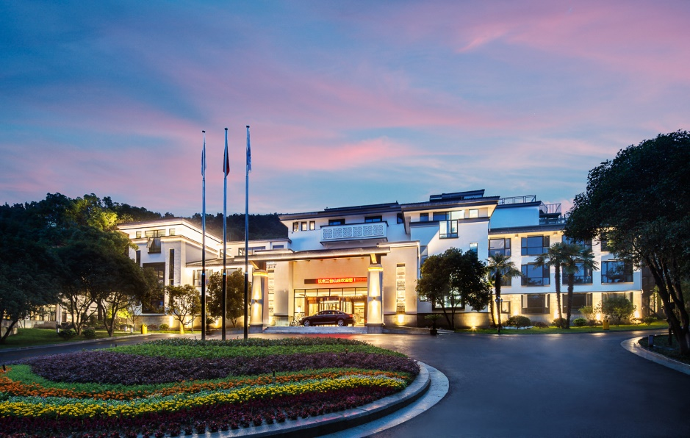
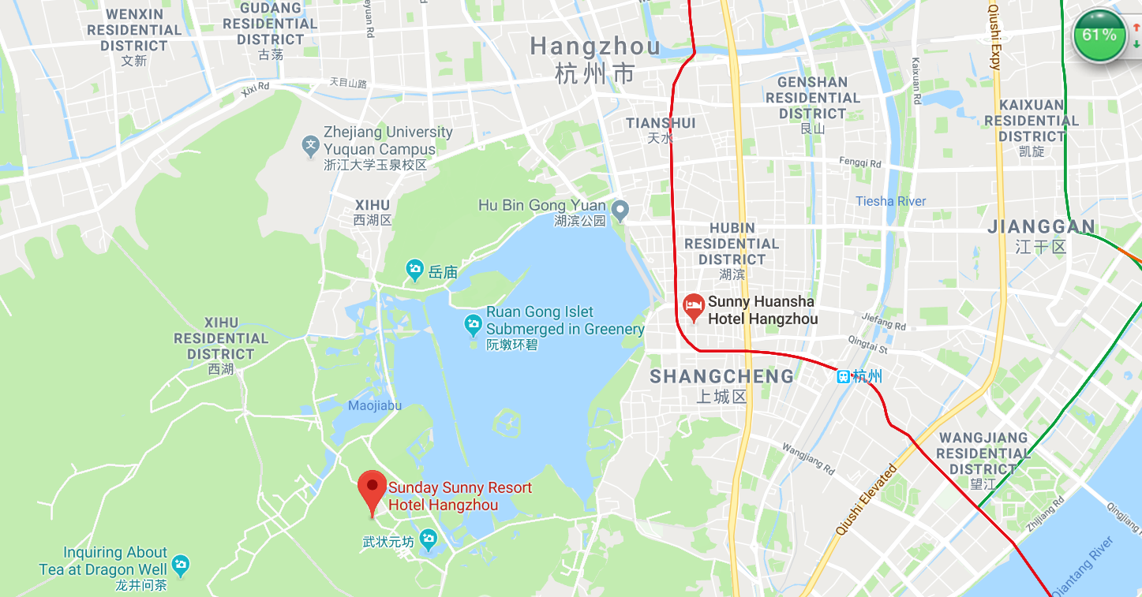

Transportation:
1.Hangzhou Xiaoshan International Airport to Hangzhou Sunday Sunny Resort Hotel:
Estimated taxi cost: 120 CNY
Estimated time by taxi: 50 to 60mins

2.Shanghai Pudong International Airport to Hangzhou Sunday Sunny Resort Hotel:
For attendees arriving at Shanghai Pudong International Airport, take Metro Line 2 ( or Taxi) to Shanghai Hongqiao railway station (上海虹桥) (about 80 - 90mins) to take high speed rail to Hangzhou Dong railway station（杭州东站). Then, take a taxi to Hangzhou Sunday Sunny Resort Hotel.

Estimated cost and time:
- From Shanghai Pudong International Airport to Shanghai Hongqiao railway station: Metro Line 2: 8 CNY; Taxi: 300 CNY; Takes about 80 - 90mins.
- From Shanghai Hongqiao railway station to Hangzhou Dong railway station: Business Class: 219.5 CNY; First Class: 117 CNY; Second Class: 73 CNY; travel time: about 50mins
- From Hangzhou Dong rail station to Hangzhou Sunny Resort, Taxi: 50 CNY, time: about 40mins

If you take a taxi from Shanghai Pudong International Airport to Sunday Sunny Resort Hotel, it will cost about 800 CNY and takes about 150 - 170mins.

The train schedule from Shanghai Hongqiao railway station (上海虹桥) to Hangzhou Dong railway station（杭州东站) is as follows:
Train number | Departure | Destination | Departure time
G7541 | Shanghai Hongqiao | Hangzhou Dong | 06:01
G1321 | Shanghai Hongqiao | Hangzhou Dong | 06:11
G7331 | Shanghai Hongqiao | Hangzhou Dong | 06:17
G7333 | Shanghai Hongqiao | Hangzhou Dong | 06:29
G7331 | Shanghai Hongqiao | Hangzhou Dong | 06:35
G1383 | Shanghai Hongqiao | Hangzhou Dong | 06:45
G7501 | Shanghai Hongqiao | Hangzhou Dong | 06:50
G1651 | Shanghai Hongqiao | Hangzhou Dong | 06:55
G7543 | Shanghai Hongqiao | Hangzhou Dong | 07:07
G2365 | Shanghai Hongqiao | Hangzhou Dong | 07:12
G1371 | Shanghai Hongqiao | Hangzhou Dong | 07:22
G7395 | Shanghai Hongqiao | Hangzhou Dong | 07:27
G1341 | Shanghai Hongqiao | Hangzhou Dong | 07:32
G1631 | Shanghai Hongqiao | Hangzhou Dong | 07:54
G85 | Shanghai Hongqiao | Hangzhou Dong | 08:00
G7503 | Shanghai Hongqiao | Hangzhou Dong | 08:04
G7549 | Shanghai Hongqiao | Hangzhou Dong | 08:10
G1653 | Shanghai Hongqiao | Hangzhou Dong | 08:15
G1337 | Shanghai Hongqiao | Hangzhou Dong | 08:25
G7325 | Shanghai Hongqiao | Hangzhou Dong | 08:30
G7357 | Shanghai Hongqiao | Hangzhou Dong | 08:36
G1509 | Shanghai Hongqiao | Hangzhou Dong | 08:42
G1373 | Shanghai Hongqiao | Hangzhou Dong | 08:55
G7505 | Shanghai Hongqiao | Hangzhou Dong | 09:00
G7349 | Shanghai Hongqiao | Hangzhou Dong | 09:10
G7581 | Shanghai Hongqiao | Hangzhou Dong | 09:16
G1655 | Shanghai Hongqiao | Hangzhou Dong | 09:23
G1377 | Shanghai Hongqiao | Hangzhou Dong | 09:28
G7355 | Shanghai Hongqiao | Hangzhou Dong | 09:46
G1347 | Shanghai Hongqiao | Hangzhou Dong | 09:51
G7587 | Shanghai Hongqiao | Hangzhou Dong | 09:58
G1501 | Shanghai Hongqiao | Hangzhou Dong | 10:03
G7351 | Shanghai Hongqiao | Hangzhou Dong | 10:08
G7507 | Shanghai Hongqiao | Hangzhou Dong | 10:13
G1657 | Shanghai Hongqiao | Hangzhou Dong | 10:18
G1301 | Shanghai Hongqiao | Hangzhou Dong | 10:23
G7589 | Shanghai Hongqiao | Hangzhou Dong | 10:34
G1349 | Shanghai Hongqiao | Hangzhou Dong | 10:48
G7509 | Shanghai Hongqiao | Hangzhou Dong | 10:58
G7461 | Shanghai Hongqiao | Hangzhou Dong | 11:04
G7599 | Shanghai Hongqiao | Hangzhou Dong | 11:10
G1375 | Shanghai Hongqiao | Hangzhou Dong | 11:15
G7537 | Shanghai Hongqiao | Hangzhou Dong | 11:29
G7317 | Shanghai Hongqiao | Hangzhou Dong | 11:34
G1327 | Shanghai Hongqiao | Hangzhou Dong | 11:39
G7511 | Shanghai Hongqiao | Hangzhou Dong | 11:53
G7591 | Shanghai Hongqiao | Hangzhou Dong | 12:01
G1387 | Shanghai Hongqiao | Hangzhou Dong | 12:20
G1633 | Shanghai Hongqiao | Hangzhou Dong | 12:25
G7335 | Shanghai Hongqiao | Hangzhou Dong | 12:30
G1369 | Shanghai Hongqiao | Hangzhou Dong | 12:40
G7375 | Shanghai Hongqiao | Hangzhou Dong | 12:51
G1659 | Shanghai Hongqiao | Hangzhou Dong | 12:57
G7595 | Shanghai Hongqiao | Hangzhou Dong | 13:04
G1389 | Shanghai Hongqiao | Hangzhou Dong | 13:10
G1353 | Shanghai Hongqiao | Hangzhou Dong | 13:25
G7305 | Shanghai Hongqiao | Hangzhou Dong | 13:30
G1329 | Shanghai Hongqiao | Hangzhou Dong | 13:42
G1355 | Shanghai Hongqiao | Hangzhou Dong | 13:47
G7515 | Shanghai Hongqiao | Hangzhou Dong | 14:00
G7353 | Shanghai Hongqiao | Hangzhou Dong | 14:05
G1303 | Shanghai Hongqiao | Hangzhou Dong | 14:10
G7539 | Shanghai Hongqiao | Hangzhou Dong | 14:15
G7575 | Shanghai Hongqiao | Hangzhou Dong | 14:19
G7347 | Shanghai Hongqiao | Hangzhou Dong | 14:30
G1635 | Shanghai Hongqiao | Hangzhou Dong | 14:35
G7583 | Shanghai Hongqiao | Hangzhou Dong | 14:40
G41 | Shanghai Hongqiao | Hangzhou Dong | 14:51
G7517 | Shanghai Hongqiao | Hangzhou Dong | 14:56
G1357 | Shanghai Hongqiao | Hangzhou Dong | 15:01
G1637 | Shanghai Hongqiao | Hangzhou Dong | 15:17
G1305 | Shanghai Hongqiao | Hangzhou Dong | 15:25
G7337 | Shanghai Hongqiao | Hangzhou Dong | 15:32
G1359 | Shanghai Hongqiao | Hangzhou Dong | 15:37
G7545 | Shanghai Hongqiao | Hangzhou Dong | 15:47
G7519 | Shanghai Hongqiao | Hangzhou Dong | 15:52
G7365 | Shanghai Hongqiao | Hangzhou Dong | 16:07
G7571 | Shanghai Hongqiao | Hangzhou Dong | 16:12
G7321 | Shanghai Hongqiao | Hangzhou Dong | 16:17
G7309 | Shanghai Hongqiao | Hangzhou Dong | 16:22
G1583 | Shanghai Hongqiao | Hangzhou Dong | 16:32
G1361 | Shanghai Hongqiao | Hangzhou Dong | 16:42
G7521 | Shanghai Hongqiao | Hangzhou Dong | 16:47
G7563 | Shanghai Hongqiao | Hangzhou Dong | 17:05
G1363 | Shanghai Hongqiao | Hangzhou Dong | 17:09
G7585 | Shanghai Hongqiao | Hangzhou Dong | 17:14
G1639 | Shanghai Hongqiao | Hangzhou Dong | 17:22
G7311 | Shanghai Hongqiao | Hangzhou Dong | 17:27
G7385 | Shanghai Hongqiao | Hangzhou Dong | 17:32
G1365 | Shanghai Hongqiao | Hangzhou Dong | 17:38
G1393 | Shanghai Hongqiao | Hangzhou Dong | 17:45
G7323 | Shanghai Hongqiao | Hangzhou Dong | 17:53
G7525 | Shanghai Hongqiao | Hangzhou Dong | 17:58
G1519 | Shanghai Hongqiao | Hangzhou Dong | 18:07
G7371 | Shanghai Hongqiao | Hangzhou Dong | 18:13
G7391 | Shanghai Hongqiao | Hangzhou Dong | 18:18
G7359 | Shanghai Hongqiao | Hangzhou Dong | 18:23
G1395 | Shanghai Hongqiao | Hangzhou Dong | 18:28
G7339 | Shanghai Hongqiao | Hangzhou Dong | 18:35
G9311 | Shanghai Hongqiao | Hangzhou Dong | 18:48
G7535 | Shanghai Hongqiao | Hangzhou Dong | 18:59
G1227 | Shanghai Hongqiao | Hangzhou Dong | 19:04
G7381 | Shanghai Hongqiao | Hangzhou Dong | 19:14
G7561 | Shanghai Hongqiao | Hangzhou Dong | 19:21
G7557 | Shanghai Hongqiao | Hangzhou Dong | 19:31
G1865 | Shanghai Hongqiao | Hangzhou Dong | 19:36
G43 | Shanghai Hongqiao | Hangzhou Dong | 19:47
G7527 | Shanghai Hongqiao | Hangzhou Dong | 20:21
G7529 | Shanghai Hongqiao | Hangzhou Dong | 20:35
G7383 | Shanghai Hongqiao | Hangzhou Dong | 20:44
G7555 | Shanghai Hongqiao | Hangzhou Dong | 20:52
G9301 | Shanghai Hongqiao | Hangzhou Dong | 21:02
G9303 | Shanghai Hongqiao | Hangzhou Dong | 21:15
G7315 | Shanghai Hongqiao | Hangzhou Dong | 21:30

